Joni Mitchell and Brandi Carlile deliver historic performance at 66th Grammy Awards, using a Sennheiser Digital 6000 system and Neumann KK 205 microphone capsules

GRAMMY-nominated artist Travis Scott performs energized medley from his latest chart-topping album, Utopia, also using Sennheiser Digital 6000

Brussels, Belgium, February 23, 2024 — History is often made at the annual GRAMMY® Awards ceremony and this year was no exception, with legendary 80-year-old Canadian singer-songwriter Joni Mitchell performing on the live broadcast for the first time in her decades-long career. The historic performance, also featuring Brandi Carlile, Jacob Collier, Blake Mills, Allison Russell, Lucius and SistaStrings, was captured with a variety of Sennheiser microphones, including Carlile and Mitchell’s own custom gold SKM 6000 handheld transmitters with Neumann KK 205 condenser capsules.

Brandi Carlile (r) performs alongside Joni Mitchell (l) during the 66th annual GRAMMY Awards, both using a Sennheiser SKM 6000 / Neumann KK 205 capsule combination (Photo Credit: Getty Images/Kevin Mazur)

Also on the awards show, which was broadcast live from the Crypto.com Arena in Los Angeles on February 4, rapper Travis Scott performed a medley of songs from his latest, GRAMMY-nominated album using an SKM 6000 with a Sennheiser MD 9235 cardioid dynamic capsule, a combination that his monitor engineer, Justin Hoffmann, calls “a game-changer.”

Folk music royalty
Mitchell has won ten GRAMMY Awards since taking home her first in 1970, for her second album, Clouds. The album includes “Both Sides, Now,” one of Mitchell’s best-known songs, which she performed on this year’s broadcast. Prior to the broadcast she won her latest GRAMMY, for Best Folk Album, for Joni Mitchell at Newport, a live recording from the 2022 Newport Folk Festival, an event she first played in 1967. Mitchell accepted the award with Carlile, who, as the album’s producer, also won a GRAMMY— her eleventh. During those earlier award ceremonies Carlile additionally won a GRAMMY in the Best Americana Performance category for Brandy Clark’s “Dear Insecurity,” on which she is featured.

Brandi Carlile’s and Joni Mitchell’s Sennheiser SKM 6000 handheld transmitter with Neumann KK 205 microphone capsule, plated in gold (Photo credit: Yvonne Murray) | 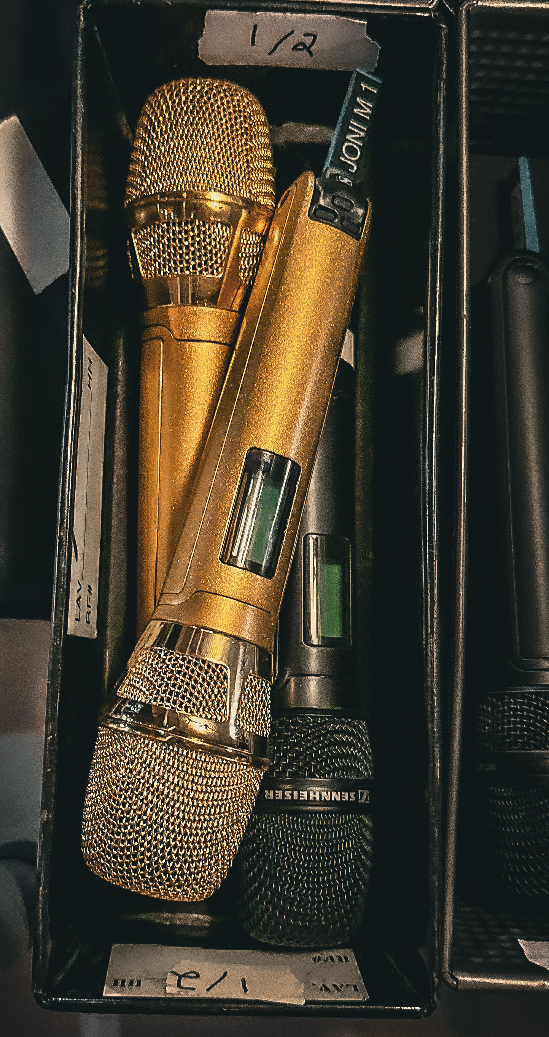

Working with the GRAMMY audio team, Sean Quackenbush, Carlile’s front-of-house engineer for the past eight years, put Sennheiser microphones on most of the musicians for Mitchell’s performance, which featured everyone seated in a semi-circle, with Collier at the grand piano. Carlile, who owns a pair of gold-plated SKM 6000s with KK 205 capsules and Digital 6000 receivers, gifted Mitchell an identical set last year for her eightieth birthday, reports Quackenbush, who brought all four mics and receivers to the Crypto.com Arena for the show following rehearsals at Mitchell’s house the day before.

For background vocals, he continues, he chose Sennheiser MMD 935 dynamic capsules for Jess Wolfe and Holly Laessig of Lucius, and Chauntee and Monique Ross of SistaStrings. “We put a pair of e 906s on Blake Mills’ amp for stereo; he’s just a genius artist. And we put a Neumann KM 184 condenser mic on Allison Russell’s clarinet, which sounded fantastic, and a KM 184 on the cello, which sounded beautiful.”

The ‘purest sound that you can possibly get’
Except for Mills and his electric fretless guitar all the musicians played acoustic instruments, Quackenbush also notes that he wanted to make sure that the FOH mixer was able to get enough gain before feedback with everyone monitoring through floor wedges. “But from the moment Joni opened her mouth it was just brilliant. There’s so much power in her voice, it’s amazing. That microphone captures and projects as if you’re standing right next to her singing in her living room. There’s no coloration. It’s the purest sound that you can possibly get.”

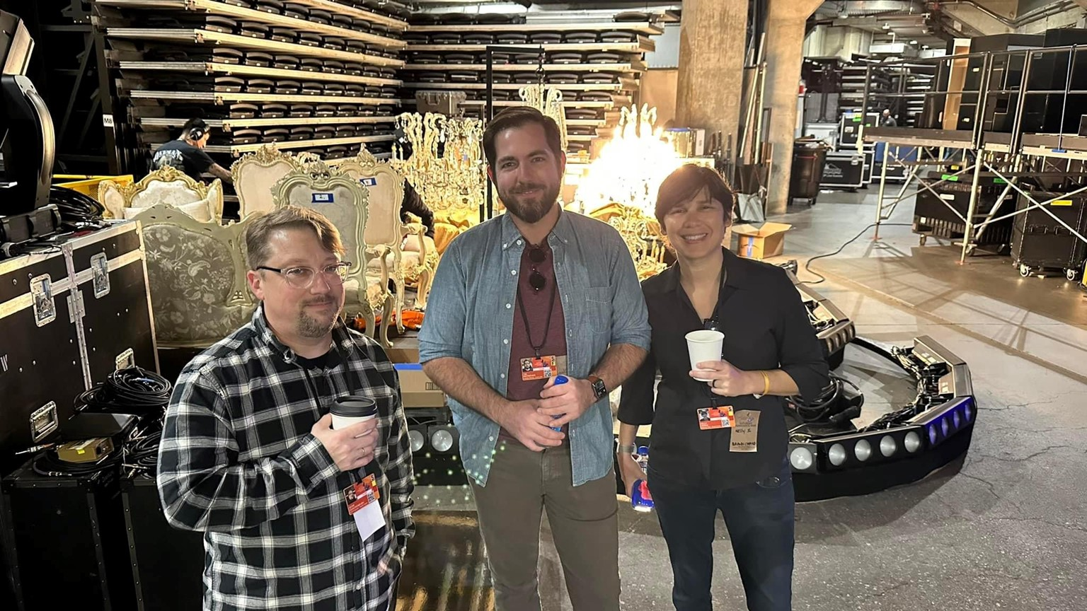 | Pictured left to right: Sean Quackenbush (FOH Engineer), Tim Reitnouer (production manager), Kellye Serna (production coordinator)  Photo credit: Yvonne Murray

Quackenbush also won a GRAMMY Award — his first — for his role as recording engineer on Joni Mitchell at Newport. The album captured Mitchell’s surprise first public performance since suffering a brain aneurysm in 2015, which temporarily took away her ability to walk or talk. “It’s Joni’s moment and Joni’s award, and I’m just fortunate enough to be a part of it,” he says. “When I showed up at the GRAMMYs 20-something years ago with Robert Randolph and the Family Band, who would have thought that years later I would win a GRAMMY?”

Travis Scott, accomplishing the best sound
“I’ve been using a Sennheiser microphone, either the SKM 5000 with the MD 5235 dynamic capsule or the SKM 6000 with the MD 9235 capsule, the last nine or 10 years,” Clair Global monitor engineer Justin Hoffmann reports. He worked with Travis Scott at this year’s GRAMMY Award telecast as his artist performed three songs — “My Eyes,” “I Know ?” and “Fe!n” — from his latest chart-topping album, Utopia, which was nominated for a Best Rap Album award this year. Scott has been GRAMMY-nominated 10 times and has won a Latin Grammy Award, Billboard Music Award, MTV Video Music Award and multiple BET Hip Hop Awards.

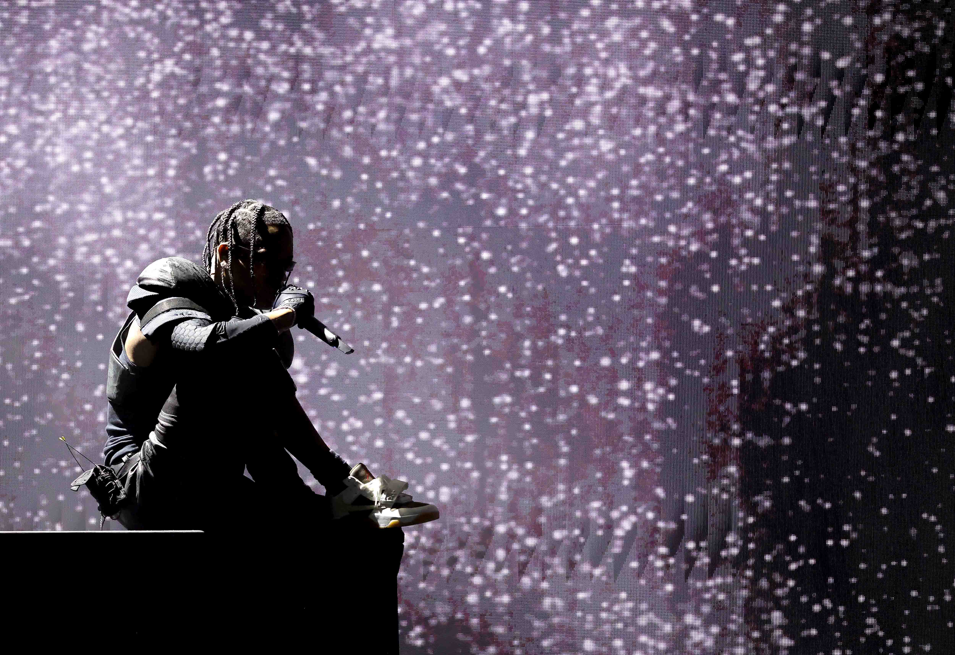
Travis Scott, singing through his Sennheiser SKM 6000 wireless transmitter / MD 9235 microphone capsule combination at the 66th GRAMMY Awards (Photo credit: Getty Images/Kevin Winter)

“It’s the only microphone I put in people’s hands,” Hoffmann says. “It doesn’t matter what the genre, what the volume level, we’re always trying to accomplish the best sound. That microphone is what makes my job easier, the artist’s job easier and the front-of-house engineer’s job easier. And it makes for a better time for the audience.”

Hoffmann likens a Travis Scott show to Korn, who were the biggest, baddest metal band on the road when he was growing up. “If you go to see a Travis show, you’ve never heard anything like it. Travis has become this generation’s biggest rap-metal star. And that microphone is at the forefront of it.”

Switching to the MD 9235 capsule was a gamechanger because of its very tight polar pattern, Hoffmann explains. “That choice originally started from the front-of-house engineer demanding that microphone all the time, because a lot of our artists are out in front of the P.A.,” he says. Plus, artists tend to hold the microphone a certain way these days. “They all want to cup the microphone. That doesn’t bother me a bit, because with that microphone it doesn’t change the tone at all. So if your artist grabs a microphone that way and you’re not using that microphone, you’re starting at a disadvantage.”

Next level customer service from Sennheiser
Neither Scott nor Hoffmann have an endorsement deal, he adds, yet Jessica Dabbs, Sennheiser Relationship Management, has always taken amazing care of them. “I’ve had a mic flown from Australia to South Africa; they had it for me in Pompeii, where we shot the movie. She’ll get that microphone to me anywhere on the globe, no questions asked, no charge. It’s that level of customer service, and the understanding that she has of how important that microphone is, that is the beginning of the whole process.”

The high-resolution images accompanying this media release can be downloaded here.

About the Sennheiser Group
Building the future of audio and creating unique sound experiences for our customers - this is the aspiration that unites the employees of the Sennheiser Group worldwide. The independent family-owned company Sennheiser was founded in 1945. Today, it is managed in the third generation by Dr. Andreas Sennheiser and Daniel Sennheiser, and is one of the leading manufacturers in the field of professional audio technology.
sennheiser.com | neumann.com | dear-reality.com | merging.com

